NOTICE OF CANCELLATION

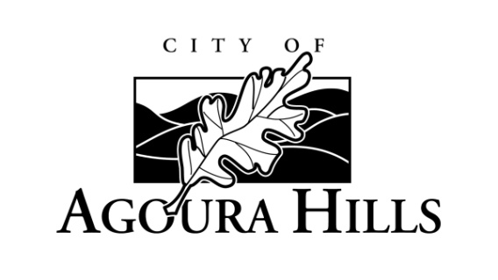

**CANCELLATION OF REGULAR MEETING**

**AGOURA HILLS PLANNING COMMISSION**

Civic Center – Council Chambers

30001 Ladyface Court, Agoura Hills, California 91301

**Thursday, March 7, 2019**

**6:30 P.M.**

The Regular Meeting of the Agoura Hills Planning Commission, scheduled for Thursday, March 7, 2019, at 6:30 p.m., is hereby canceled, due to a lack of business to be transacted.

CANCELLATION

The next Regular Meeting of the Planning Commission is scheduled for Thursday, March 21, 2019.

Dated: February 28, 2019

_____________________________

Kimberly M. Rodrigues, MPPA, MMC

City Clerk