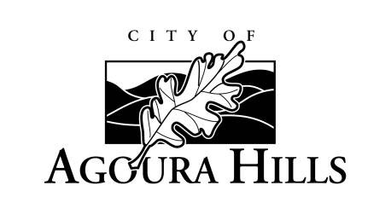

COURTESY NOTICE

You are receiving this courtesy notice, as you asked to be informed of matters involving the Agoura Village Specific Plan and/or the Agoura Village East (AVE) Project, which is a proposed mixed-use development at the southeast corner of Kanan and Agoura Roads in the City of Agoura Hills.

The City of Agoura Hills Community Development Director has approved a Temporary Use Permit for the AVE Project applicant to install a fence on the property. At this early stage, testing is being conducted by the project applicant. The City has not approved the AVE Project and no construction is occurring.

For questions or concerns, please contact:

Project Applicant:

Lou Mellman or Garry Collett

California Commercial Investment Group

(805) 495-8400

[lou@ccinvest.com](mailto:lou@ccinvest.com) or [collett@ccinvest.com](mailto:collett@ccinvest.com)

City of Agoura Hills staff contact:

Allison Cook, Assistant Planning Director

(818) 597-7310

[acook@ci.agoura-hills.ca.us](mailto:acook@ci.agoura-hills.ca.us)