# PERMIT INFORMATION:

Electric vehicle charging stations (EVCS) must be installed in accordance with the manufacturer’s installation instructions and in accordance with the 2022 California Electrical Code. The EVCS must be listed by a nationally recognized testing laboratory (NRTL).

# THINGS TO KNOW:

* A Building Permit may be issued only to a State of California Licensed Contractor or the Homeowner**.** If the Homeowner hires workers, State Law requires the Homeowner to obtain Worker’s Compensation Insurance.
* When a permit is required for an alteration, repair, or addition exceeding one thousand dollars ($1,000.00) to an existing dwelling unit that has an attached garage or fuel-burning appliance, the dwelling unit shall be provided with a Smoke Alarm and Carbon Monoxide Alarm in accordance with the currently adopted code.

**TYPES OF ELECTRIC VEHICLE (EV) CHARGERS**: There are 2 basic residential types of EV chargers for home use: Level 1 and Level 2

* LEVEL 1: Level 1 chargers are smaller units that plug directly into a standard 120-volt receptacle outlet. If you are installing a new 120-volt receptacle outlet for the charger, you will need to obtain a permit and a single line diagram is required.
* LEVEL 2: Level 2 EV charging system requires a 240-volt electrical circuit and charges the vehicle battery much faster than a Level 1 charger. Level 2 charger installation requires an electrical permit and inspections of the installation. In order to obtain the permit, you will need to provide some basic information to show that your existing electrical service can handle the added load such as a single line diagram and a load calculation sheet.
* **IMPORTANT NOTE:** Verification shall be made that the existing main service panel and all panels in the electrical system used for the EVCS are safe and free of electrical hazards. If electrical violations or hazards are present the Owner/Contractor will be required to have a licensed contractor correct the violations and/or hazards. Damaged equipment must be replaced or repaired and will require permits and inspections.

# PLAN SUBMITTAL REQUIREMENTS:

Complete sets of building plans/reports and documents are required for the plan check of the proposed construction. All dimensions and scales shall be clearly indicated on the plans.

# FORMS REQUIRED AT SUBMITTAL:

* + Building Permit Application
  + Owner/Builder Form*, if applicable*
  + Two (2) Sets of Floor Plans, 8 ½” x 11” minimum size
  + Two (2) Sets of the Manufacturer’s Installation Instructions.
  + ***Two (2) Copies of the Property’s Electrical Service Load Calculations per CEC Article 220 and a single line electrical diagram***. *Make sure to include the EV Unit in the Calculation.*

*The following are guidelines for the preparation and submittal of your plans. Specific plan requirements will depend largely upon the extent, nature, and complexity of the work to be done.*

* Property Information - Address of Property and Name, Address, Contact Phone Number of Property Owner; Applicable Codes; Occupancy and Type of Construction and Description and Scope of Work.
* Site plans showing the location of the building, street, existing trees, all charging stations, electric service, conduit location, and disconnects.
* A single line diagram must be included in the submittal with the following information:
  + Conductor types and sizes
  + Size of the overcurrent device (circuit breaker) supplying the EVCS
  + Conduit size, type, and location
  + The manufacturer and model of the charging stations
  + The size of the main electric panel, distribution panels (sub-panels), and disconnects.
  + Provide photographs of the main and sub-panels.
  + Type charging station
* Electrical Load Calculation Sheet: Provide the size of the existing electrical panel, existing load on the panel, and proposed load/circuits from the electric vehicle charging system in order to determine if there is adequate capacity in the existing panel. (CEC 220).

# PLAN CHECK PROCESS:

* Plans for Electric Vehicle Charging Stations can generally be performed within 5 days or OTC if staff is available.

# GENERAL REQUIREMENTS:

* Verify that the existing main service panel and all panels in the electrical system used for the EVCS are safe and free of electrical hazards. If electrical violations or hazards are present the Owner/Contractor will be required to have a licensed contractor correct the violations and/or hazards. Damaged equipment must be replaced or repaired and will require permits and inspections.
* EVCS shall be listed by a nationally recognized testing laboratory (i.e., UL) in compliance with UL 2202 “Standard for Electric Vehicle (EV) Charging System Equipment.” (CEC 90.7)
* The electric vehicle charging system shall be installed in accordance with the manufacturer’s guidelines and shall be suitable for the environment (indoor/outdoor).
* Electrical Vehicle Supply Equipment shall be protected against vehicle impact damage when located in the path of a vehicle. In order to avoid the installation of a substantial pipe bollard as an equipment guard, locate the Electrical Vehicle Supply Equipment on a garage side wall, out of the vehicular path
* If a separate meter will be installed for the electric vehicle charger, it shall be 48” and 66” above the ground. If a single mast is to be used to serve the meters, the service entrance conductors shall be sized for the sum of the two meters, based on the table below (CEC Table 310.15(b)(7)(1) thru (4)

|  |  |  |  |
| --- | --- | --- | --- |
| **SERVICE ENTRANCE CONDUCTOR SIZE AND RATING** | | | |
| **Service or Feeder Rating** | **Copper Conductors** | **Aluminum or Copper-**  **Clad Aluminum** | **Minimum Conduit Size** |
| 100 AMPS | #4 AWG | #2 AWG | 1 ¼ Inch |
| 125 AMPS | #2 AWG | #1/0 AWG | 1 ¼ Inch |
| 150 AMPS | #1 AWG | #2/0 AWG | 1 ¼ Inch |
| 200 AMPS | #2/0 AWG | #4/0 AWG | 1 ½ Inch |

The table below illustrates the type and size of wire and conduit to be used for various Electric Vehicle Charger circuits. All EVC breakers shall be full space (no quad breakers).

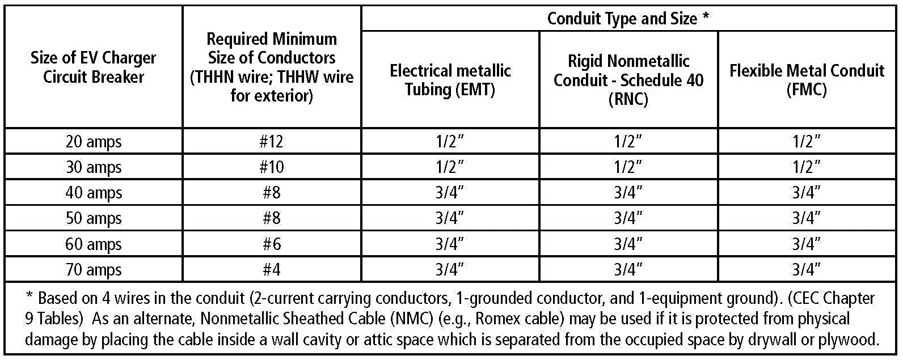

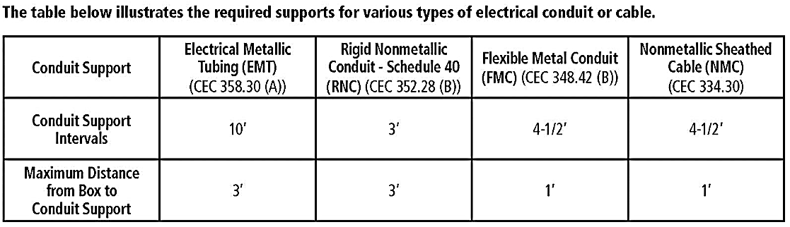

In addition to the above-noted requirements, the California Electrical Code contains many other provisions that may be applicable to the installation of a new electrical circuit. Installers are cautioned to be aware of all applicable requirements before beginning the installation. For additional information or guidance, consult with the Building and Safety Division staff or a qualified and experienced Electrical Contractor.

# SERVICE LOAD CALCULATOR:

Instructions: Review the list of electrical loads in the table below and check all that exist in your home (don’t forget to include the proposed Level 2 charger). For each item checked, fill in the corresponding “Watts Used” (refer to the “Typical Usage” column for wattage information). Add up all the numbers that are written in the “Watts Used” column and write that number in the “TOTAL WATTS USED” box at the bottom of the table. Then go to the next page to determine if your existing electric service will accommodate the new loads.

**Note:** Loads shown are rough estimates; actual loads may vary. For a more precise analysis, use the nameplate ratings for appliances and other loads.

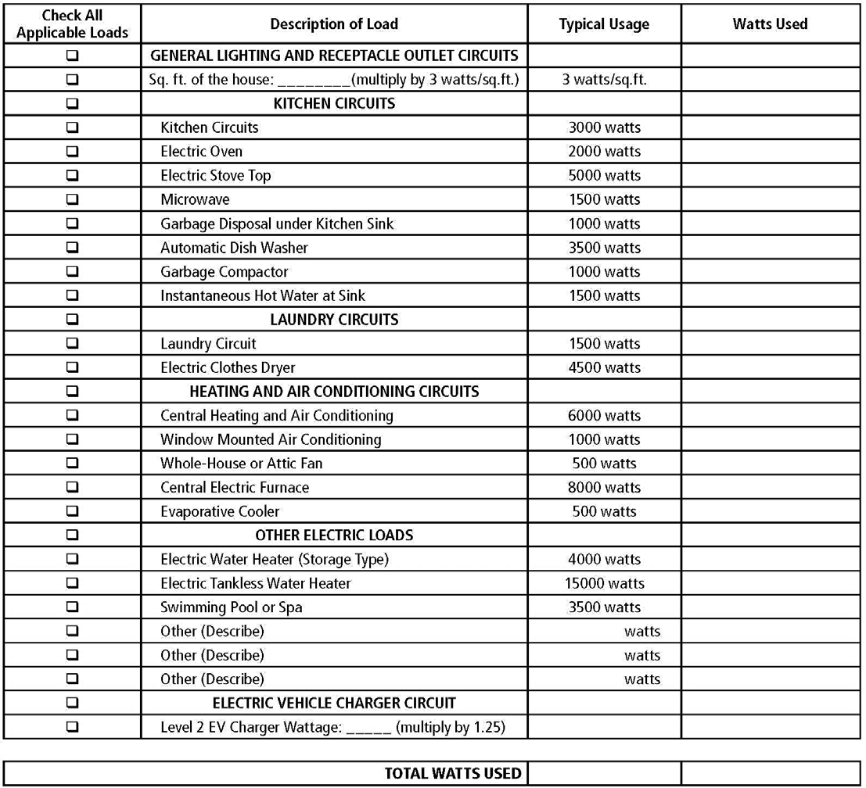

# The table below is based on CEC 220.83(A) and Annex D.

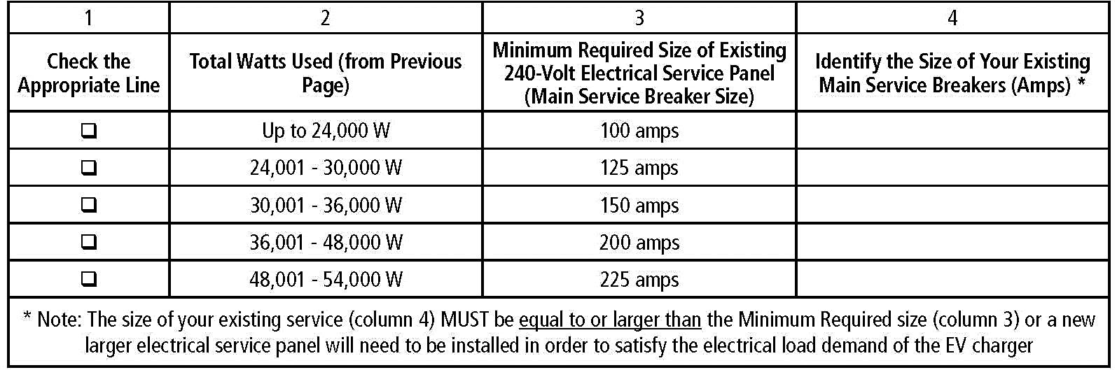

**INSPECTION REQUIREMENTS:**

One inspection is required after the new wiring and charger unit is installed. However, additional inspections may be required depending on the scope of work. The building inspector will let you know if there are additional inspections. The manufacturer’s installation guidelines shall be available for the building inspector at the job site during the inspection.

A representative of the installing contractor must be onsite for all inspections. The representative must have an understanding of the project and be able to perform all requirements of the following checklist:

* PROPERTY OWNER shall complete the “Affidavit Self-Certification for Compliance of Smoke and Carbon Monoxide Detectors” form, verifying that they have installed the required smoke and carbon monoxide detectors in their home/property.
* The permit holder will need to be present during the inspection so that the Building Inspector can access the location of the electrical meter and EV charger (typically in the garage) and perform torque requirements.
* All Electrical Vehicle Charging Systems shall comply with the applicable sections of the California Electrical Code, including Article 625.
* Verify installation matches the approved set of plans. If not, a revision is required.
* A lockable disconnect is required in a readily accessible location (*CEC 625.43*) for EV charging stations > 60A or 150V to ground. The disconnecting means shall be legibly marked to indicate its purpose unless located and arranged so the purpose is evident. The marking shall be of sufficient durability to withstand the environment involved. (CEC 110.22)
* Provide working clearances at all electrical equipment. (36” deep x 30” wide x 6’6” high) (*CEC 110.26)*
* All new and existing circuit breakers shall be listed to be used with electrical panel
* All new and existing circuits must be labeled.
* Verify load calculations attached to the job copy.
* Gas meter clearances: There shall be no electrical equipment, conduit, conductors 10’ above the gas meter or within 18” of the service riser.
* Verify grounding electrode system: For new or remodels the primary electrode be a 20’ of # 4 rebar OR 20’ of minimum 4 AWG bare copper wire placed 3” from the bottom of the footing (if no footing, use (2) 8’ long by 5/8” ground rods spaced a minimum of 6’ apart). In addition to the primary grounding electrode a metal water pipe supplemental electrode is required and must be connected with a minimum 4 AWG copper wire and connected at the exterior hose bib where the water service enters the building.
* Note: For sizing the GEC for services over 200 AMP’s refer to NEC/CEC Table 250.66
* If the electric vehicle charging equipment is located in an area subject to vehicular damage, an adequate barrier must be installed (e.g. 4” diameter steel pipe filled with concrete, a minimum of 40” above the finished floor/grade, installed in a footing measuring 12” in diameter and 3’ deep). (CEC 110.27)
* Supports: EMT, IMC, and RMC shall be securely fastened in place at least every 10’ and within 3’ of each outlet box, junction box, device box, cabinet, conduit body, or other termination. *CEC 342.30 (A), 344.30 (A), 358.30 (A)*
* Where EVSE are not mounted on a wall, they must mount on a metal post
* The coupling means of the Electric Vehicle Supply Equipment shall be stored at a height of not less than 18 inches above the floor level for indoor locations and not less than 24 inches above the grade level for outdoor locations. (CEC 625.50)

# TORQUE REQUIREMENTS

* All associated EVSE breakers must be verified for proper torque.
* Torque all connections per manufacturer’s listing. (Electrical contractor to be onsite with a torque wrench and torque screwdriver of the audible type. (Ratcheting). (CEC 110.3 (b))
* Secure lugs with channel locks to hold lug in place when applying the proper torque.
* Verify all torque connections. (For example: Polaris connectors in junction boxes)

# TOOLS REQUIRED FOR INSPECTION:

* + Torque screwdriver, Torque wrench (and associated sockets), Square tip and standard/slot tip (extra-long/deep), Channel locks, Phase tape, Ladder (as required)