**Furnace in Attic Location**

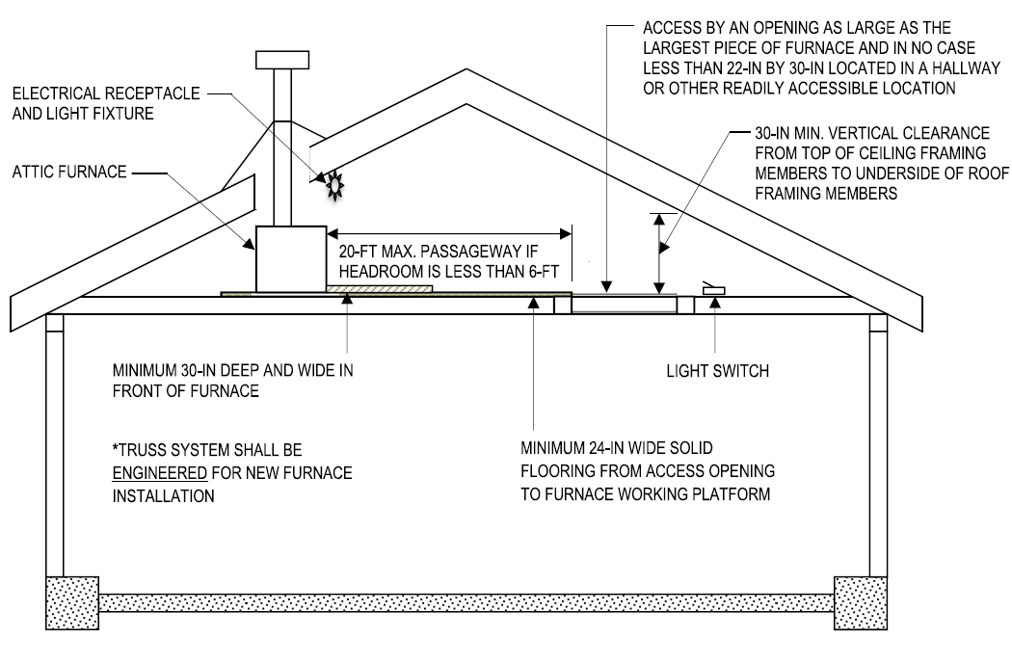

**Appliances in Attics**

The following regulations apply to a furnace appliance when located in an attic in accordance with the 2022 CMC 304.4, CMC 904.9, and 2022 CRC R807.1.

* **Access**. At least as large as the largest component of the appliance and not less than 22-in. x 30-in.
* **Passageway Length**. When the height of the passageway is less than 6-ft. distance from the passageway access to the furnace shall not exceed 20-ft.
* **Passageway Width**.A passageway shall have solid flooring not less than 24-in wide.
* **Work Platform**. A level working platform 30-in deep x 30-in wide in front of the service side of the unit.
* **Lighting and Outlet**. A permanent 120-volt receptacle and light are located near the unit with the switch controlling the lighting fixture located at the access opening.
* **Furnace**.
  + Upright furnaces may be installed in an attic, furred space, or under-floor spaces more than 5-ft in height, provided the required listings and furnace and duct clearances are observed.
  + Horizontal furnaces may be installed in an attic, furred space, or under-floor spaces, provided the required listings and furnace and duct clearances are observed.
* **Clearances**. Minimum clearances from combustibles shall comply with the listing of the appliance.