**BUILDING DIVISION REQUIREMENTS**

An electrical permit is required for replacement and upgrade of the main electrical service panel prior to installation of the new panel. Following is a listing of the general requirements for electrical panel replacements based on the 2019 California Electrical Code. This Informational Handout is intended to provide general information, contact the Building Safety Division for any questions or additional information.

* **General Requirements -** The main electrical service shall be installed with rigid conduit. Electrical metallic tubing may be used where the service drop is attached to the building. The service entrance cable may be used, provided the approved fittings are used with the cable, such as a rain-tight service head or forming the cable goose-neck, taped or painted, and held securely in place by a fitting approved for the purpose. (Article 230)

The minimum size service conduit shall be 1-1/4”. The minimum size service entrance wire shall be rated 100 amperes minimum for single-family dwellings. For single-family homes, the service disconnect means shall have a rating of less than 100 amperes, 3-wire. A larger service may be required for new homes or additions to existing homes based on the actual load calculations. (CEC 230.79(C))

* **Service Entrance Conductors (Wires)** – Conductors that extend across a roof shall have a minimum vertical clearance of 3’ above the roof surface for roofs sloped 4:12 or more (18” clearance required when conductors enter through the roof overhang/eave). The service head shall be located so that the service drops, together with the open wires between the service head and service drop, will have a minimum clearance of 10’ vertically above ground and 3’ radius from doors and windows. (Article 230.24)

The neutral (grounded) conductor must be identified with white tape at both terminals. (Article 200.6(B)(4))

Service entrance conductors and cables shall be approved for a wet location and, when exposed to direct sunlight, shall be listed and marked as “sunlight resistant.” Service entrance conductors and conduit shall be sized according to the following table (based on CEC Chapter 9 table 1):

|  |  |  |  |
| --- | --- | --- | --- |
| **SERVICE ENTRANCE CONDUCTORS SIZE AND RATING** | | | |
| **Service or Feeder**  **Rating** | **Copper**  **Conductors** | **Aluminum or Copper-Clad**  **Aluminum** | **Minimum Conduit**  **Size** |
| 100 Amps | #4 AWG | #2 AWG | 1 ¼ inch |
| 125 Amps | #2 AWG | #1/0 AWG | 1 ¼ inch |
| 150 Amps | #1 AWG | #2/0 AWG | 1 ¼ inch |
| 200 Amps | #2/0 AWG | #4/0 AWG | 1 ½ inch |

*The grounding conductors must be identified by white or grey tape at both ends (200.6).*

* **Meter location** – SCE requires the height of the meter to be 48” to 66” above the ground. SCE prohibits new meters on exterior walls adjacent to bedrooms or bedroom closets. A minimum horizontal clearance of 36” from the gas meter and piping is required.
* **Working space** - The clear working space in front of the panel shall be 30” wide by 36” deep with a minimum headroom clearance of 6’-6” (Article 110.26)
* **Grounding of Services -** Grounding shall consist of a continuous grounding electrode conductor run from the panel to a ground rod (grounding electrode) and to the cold water pipe. Grounding of the electrical service at the main water line must be within the first 5’ of water piping into the building. The underground water service shall not be used as the grounding electrode without a supplemental electrode. [CEC 250.52 (A)(1) and 250.53 (D)(2), 250.68(C)]

For new structures and additions to existing structures, a concrete-encased ground electrode shall be installed. This shall consist of 20’ of ½” bare or zinc-coated rebar or bare copper wire in the portion of the footing in contact with earth. (CEC 250.52(A)(3)(1) and 250.52(A)(3)(2))

For existing structures, the grounding electrode shall be nonferrous (copper), listed, and not be less than 5/8” in diameter. The electrode shall be installed such that at least 8’ of length is in contact with the soil. The upper end of the electrode shall be flush with or below ground level unless the above-ground end and the grounding electrode conductor attachment is protected against physical damage. (CEC 250.52 (A)(5), 250.64(B))

The required grounding electrode conductor (from electrode to panel) size is listed in the following table:

|  |  |  |
| --- | --- | --- |
| **GROUNDING ELECTRODE CONDUCTOR SIZING (Table 250.66)** | | |
| **Size of Main Panel** | **Copper Conductors** | **Aluminum or Copper-Clad Aluminum** |
| 100 Amps | #8 AWG | #6 AWG |
| 125 Amps | #8 AWG | #6 AWG |
| 150 Amps | #6 AWG | #4 AWG |
| 200 Amps | #4 AWG | #2 AWG |

* **Bonding** - Bonding of the hot, cold, and gas lines is required when the electrical panel is replaced. Bonding of the hot, cold, and gas lines is required with water service replacements (if using a less conductive material than is existing) and for all re-pipes. Bonding shall consist of a continuous bond jumper installed at the water heater between the hot, cold, and gas lines. The bonding jumper shall be sized based on the following table. (CEC250.4(A)(4))

|  |  |  |
| --- | --- | --- |
| **BONDING JUMPER SIZING (Table 250.102(C)(1))** | | |
| **Size of Main Panel** | **Copper Conductors** | **Aluminum or Copper-Clad Aluminum** |
| 100 Amps | #8 AWG | #6 AWG |
| 125 Amps | #6 AWG | #4 AWG |
| 150 Amps | #6 AWG | #4 AWG |
| 200 Amps | #6 AWG | #4 AWG |

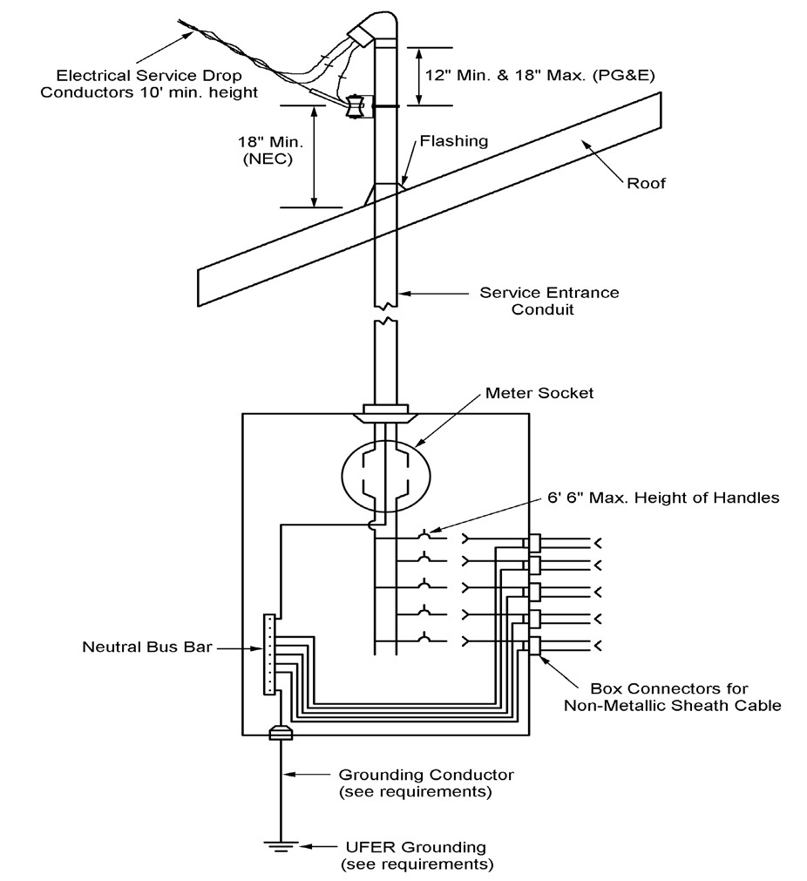

|  |  |
| --- | --- |
| **Building Permit Application**   * A completed Building Permit Worksheet application * If a panel is to be relocated, coordinate with SCE for the new location.   **Inspections**  A minimum of two inspections are required, a utility release and a final. The utility release inspection should be scheduled when the new panel is installed and ready to be hooked up the SCE supply. The dead-front panel shall be removed at this inspection (the inspector will not remove the dead-front panel). The building inspector will provide a utility release form which will need to be provided to SCE to have the supply hooked up to the new panel. A wire lath inspection is required for stucco repairs. A final inspection should be scheduled after all of the work is complete. |  |